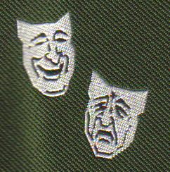

The Abadan Society International Reunion

September 2009
Friday 25th to Sunday 27th for Main Reunion

Monday 28th to Wednesday 30th for Optional Tours

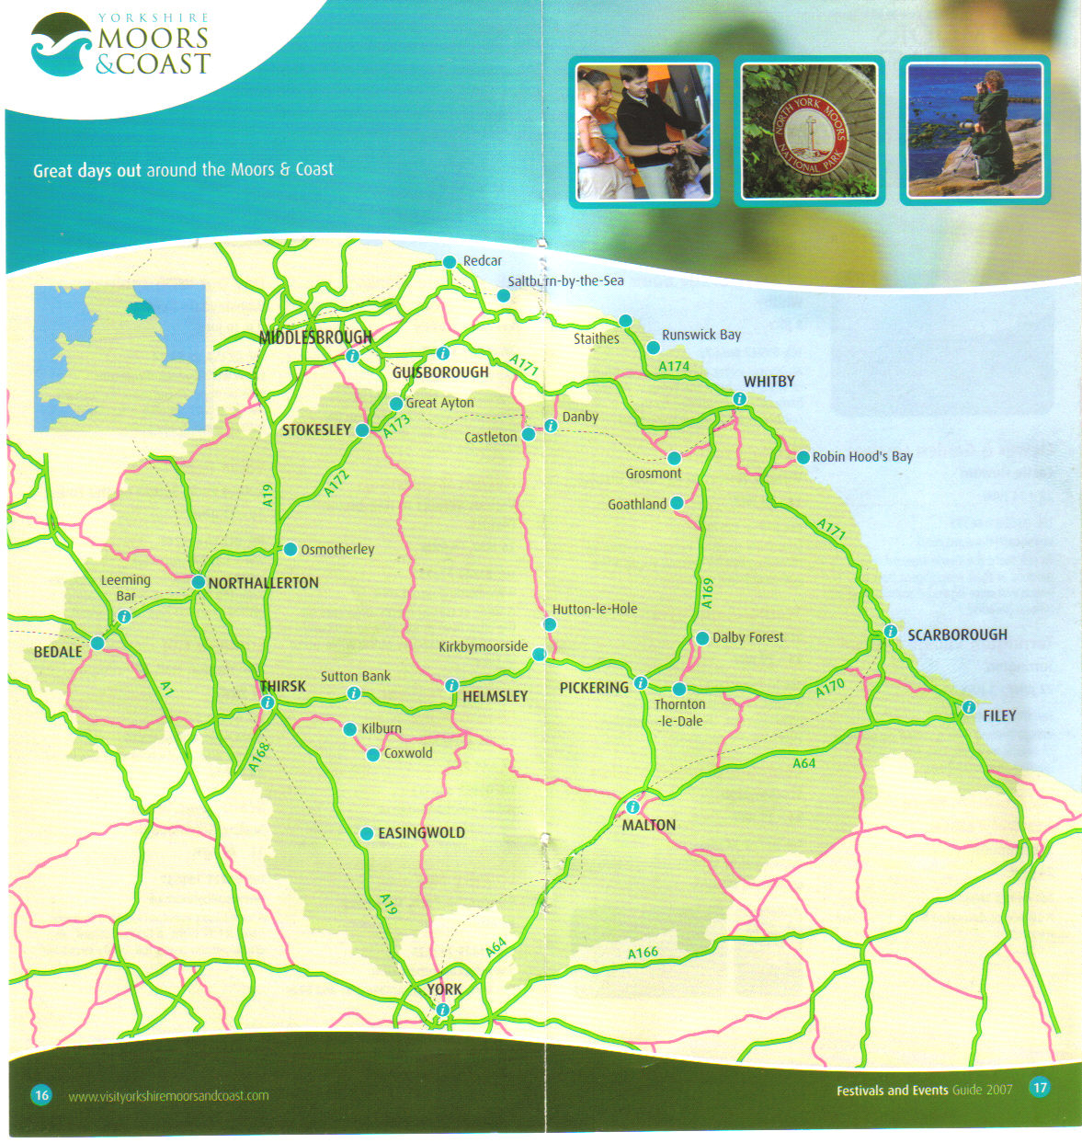
NYMR
Start
NYMR
Finish

Heartbeat
Country

Castle Howard
Yorkshire
Lavender
James Herriot

