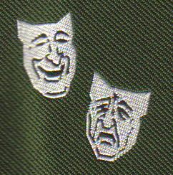

The Abadan Society International Reunion

September 2009
Friday 25th to Sunday 27th for Main Reunion

Monday 28th to Wednesday 30th for Optional Tours

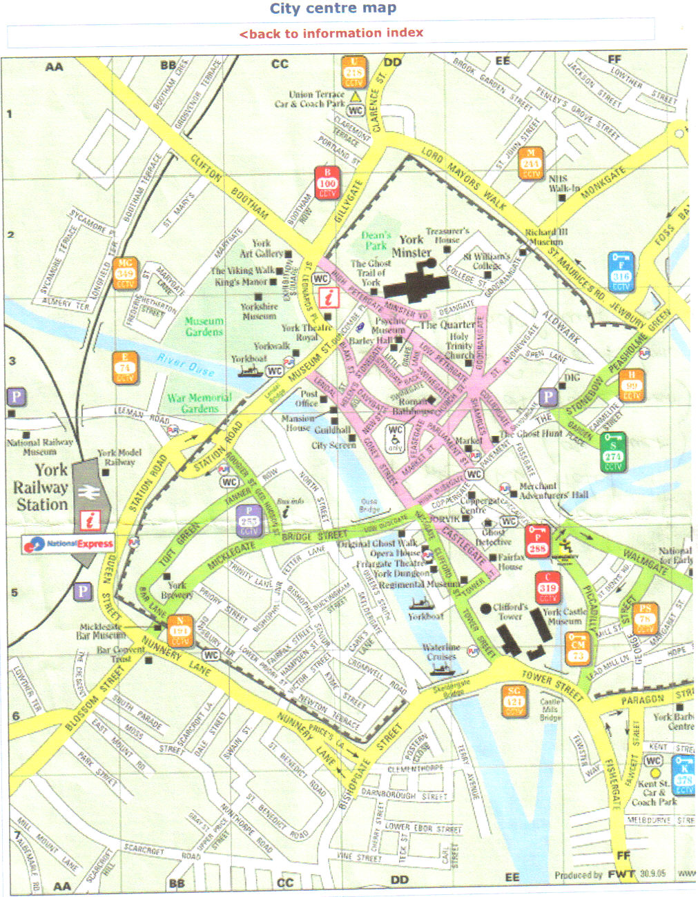
Hilton Hotel
Tower Street
York Boat
King’s Staith
Landing

