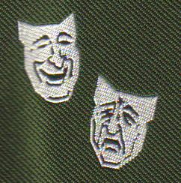

The Abadan Society International Reunion

September 2009
Friday 25th to Sunday 27th for Main Reunion

Monday 28th to Wednesday 30th for Optional Tours

Reunion Events Response Proforma

Date | Event | Cost per  Person  UK£ | Cost per  Person  US$ | No of  Persons | Total Cost  UK£ or US$
 | Administration Fee | 7.00 | 12.6
Friday 25th | Evening Reception  With Finger Buffet | 14.20 | 25.6
Saturday 26th | City Tour with  Guide | 4.80 | 8.6
Saturday 26th | Dinner Dance with  Disco | 40.00 | 72
Sunday 27th | Lunch Cruise on the  River Ouse | 32.00 | 57.6
Monday 28th | Castle Howard and  Lavender Farm | 24.00 | 43.2
Tuesday 29th | North Yorks Moor  Railway and Whitby | 28.00 | 50.4
Wednesday 30th | James Herriot Country  And Museum | 20.00 | 36
Grand
Total

Name(s) of participants ____________________________________________________

Address ___________________________

___________________________

___________________________

___________________________

Phone No ____________________ e-mail ________________________

---------------------------------------------------------------------------------------------------------------------------------------
Please make cheques payable to “Abadan Society” and return to the Reunion Treasurer, Capt. Roy Harris along with the completed form above (UK, European, Canadian and Rof W participants). USA participants should send monies to Mr Tom Reif
Payments should be made as follows 10% by 28th February 2009; final balance by 1st May 2009 (the organisers would prefer one payment when you book and no later than 1st May 2009)

Please note participants must book the Hilton Hotel by themselves; see attached letter

