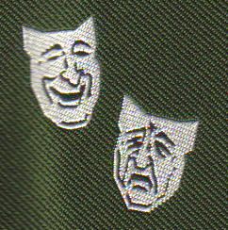

The Abadan Society International Reunion

September 2009
Friday 25th to Sunday 27th for Main Reunion

Monday 28th to Wednesday 30th for Optional Tours

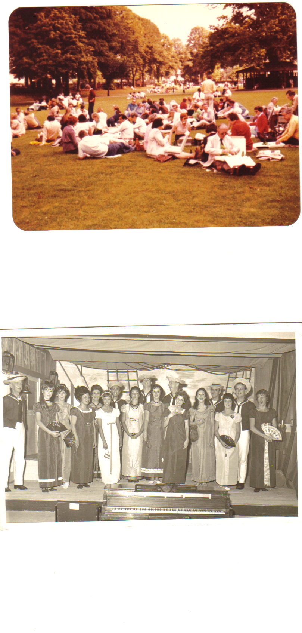

HMS Pinafore May 1967

First Reunion 1981 at Windsor

